**SHANTHIMALAI TRUST**

**ACTIVITIES REPORT FOR THE YEAR 2016-2017**

Shanthimalai Trust has been concentrating in the upliftment of downtrodden people in and around Tiruvannamalai especially in spiritual awakening, poverty alleviation, education, health awareness and treatment of diseases with a holistic approach in medicine. Since all-out efforts are made in each of the above fields, not only the villagers’ general outlook to life changed greatly, but they also have resulted in a considerable economic development and improvement in the standard of living. Shanthimalai Trust consists of the Yoga/Meditation Centre, which coordinates and supports the below mentioned activities, in the fields of Poor and Needy charity and health.

**Help to Poor & Needy**

The vil­lag­ers are suf­fer­ing due to illit­er­acy, pov­erty, poor health and sani­tary con­di­tions, lack of employ­ment oppor­tu­ni­ties and eco­nomic activi­ties, emo­tional approach to issues, super­sti­tions, beliefs, age old cus­toms, con­ven­tions and the like. They are often unable to take care of their aged par­ents and oth­ers as they do not have proper where­withal even to take care of them­selves. Due to that aged peo­ple often suf­fer a ter­ri­ble des­tiny of neg­li­gence by their fam­ily mem­bers and often live in unwor­thy con­di­tions.

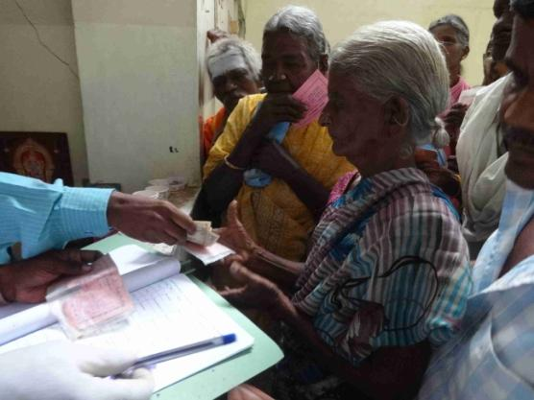

Poor & needy receiving cash

Shan­thi­malai Trust has a monthly pen­sion scheme to help these peo­ple who are in the eve­ning of their lives and are not cared by the younger gen­era­tion or where there is nobody to take care. Under this scheme, about 650 old and dis­abled per­sons are helped by pro­vid­ing them cash amounts rang­ing from Rs. 300/- to Rs. 1000/- per month. In addition during the times of severe flooding we provided mats, clothes, buckets and pots to the affected people.

Due to this ­sup­port of the eld­erly per­sons, their rela­tives get inspired to rec­og­nise their duty and to also ren­der sup­port in their own fami­lies.

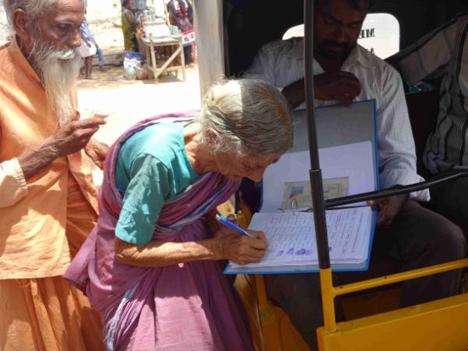

Poor & needy receiving help in their village

Medi­cal help is pro­vided to those pen­sion­ers when­ever they need treat­ment in the clinic, in other health insti­tu­tions or hos­pi­tals, like in the fields of eye, den­tal, dia­be­tes and sur­gi­cal care.

50% of the Poor & Needy bene­fi­ci­ar­ies are not in a posi­tion to pick up their con­tri­bu­tion from the office. Those per­sons receive cash from our staff in their vil­lages.

**Sri Sundaram and AlagammalNursery&Primary School, Atiyandal**

Since 3 years our Sri Sundaram and Alagammal School is operating as a Nursery &PrimarySchool. In order to avoid major investments for construction of a compound wall the classes 6 – 8 were shifted in 2014 year to the campus of our Higher Secondary School in Kaveriyampoondi.

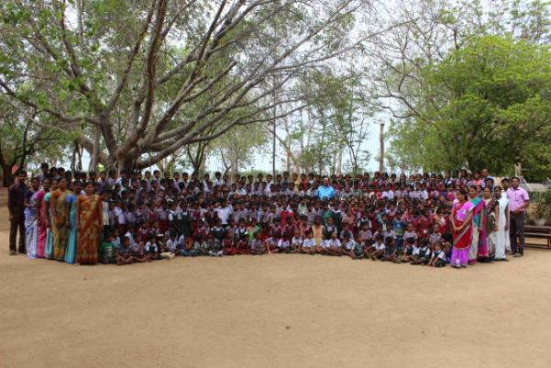

In the past academic yearour school accommodated327 students, 17 teaching staff and 3 supporting staff.

To tone up the mental and physical standard along with co-curricular activities, daily prayer, meditation, singing, dancing and sports and games have been incorporated in our syllabus.

Parents meetings are being conducted throughout the year. In each of the 5 meetings such important topics as:

- The impor­tance of food, of a bal­anced diet, of dis­ci­pline and punc­tu­al­ity, docu­men­ta­tion of new admit­ted, of hygiene, clean­li­ness of dresses, brush­ing teeth, comb­ing and bath­ing and the impor­tance also not to be too strict about these issues.

- The importance of developing values, which serve as guidelines and priority markers in the course of life, of interest and motivation to reach high goals of life and the importance to commit oneself to the needs of others and society.

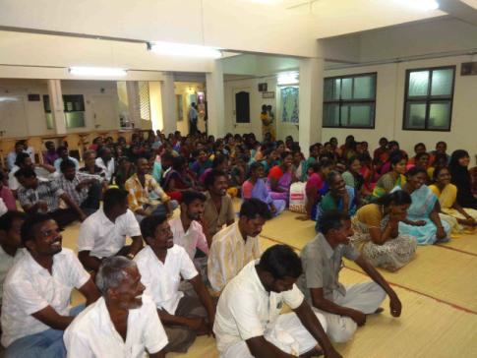

Parents meeting

To emerge and develop the leadership quality and team spirit the children were classified into the four houses Cheran, Cholan, Pandiyan andPallavan.

On every Saturday audio-visual sessions were being held for students pertaining to their subjects, natural science and moral values. Free medical camp and routine medical check-ups along with treatment was organized through Sri Ramana Maharishi Health Society. All children received one free nutritious meal per day.

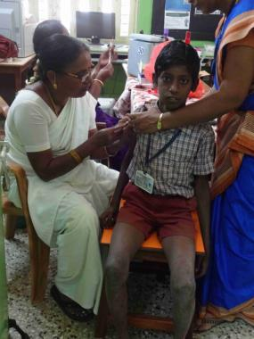

Medical camp

In memory of national importance the 70thIndependence Day was celebrated on August 15th. Mrs.Selvi, Assist Educational Officer (AEO), TVM,presided the function, delivered her special address and distributed the prizes.

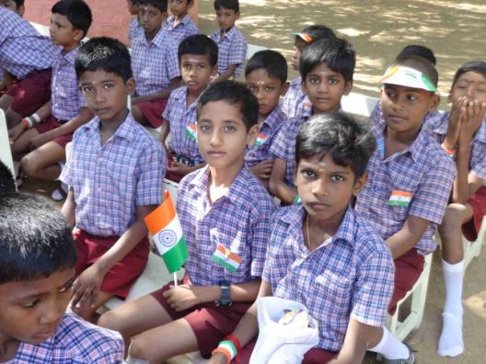

On 26th ofJanuary the 68th Republic day and Annual sports day celebration took place. Mrs. M. Malathy, Ex Principal of our andGovernment school, chaired the function, gave a special address and distributed the prizes to the winners of the Annual Sports day.

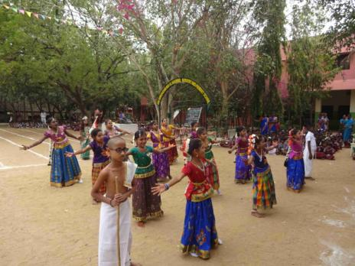

On March 21st 2017 the **World For­est Day** was cele­brated in our school dur­ing the morn­ing prayer.Our 5th stan­dard chil­dren per­formed a drama about defor­es­ta­tion, the result­ing prob­lems and the world's facing of a mourn­ful situa­tion.All the stu­dents took an oath to save trees and plan­ta­tions.

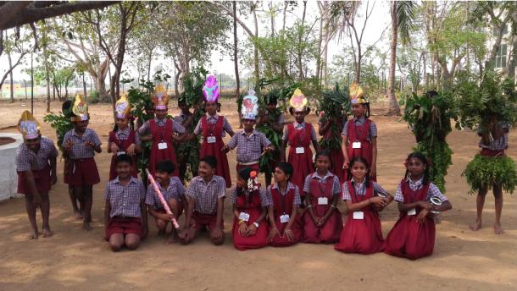

In order to build the co-curricular activity, we offered classes in singing, dancing,drawing,poems writing,recitation, album making and making of life oriented models.

In order to develop interest in all subjects we are helping the children to make subject oriented models and do practicals in our science lab. Each lesson is being taught on audio-visual basis. In the annual science exhibition the children showed their talents to express, what they have understood.

The academic year 2016 – 2017 ended on April 20th 2017.

**Professional Training Programme (PTP - After school education)**

The need and zeal for higher education is obviously seen growing much faster among the students. Therefore based on the performance, attitude and interest, our support was extended to 414 students (199 male and 215 female) to cover the expenses for their institution/college course fees, tuition fees, uniforms, text books, note books, exam fees, lab and working tools, the students have access to reference and lending library facilities. They are going for Graduation, Post-Graduation, Diploma, Engineering, Medicine, Management, Teacher’s training, Nursing, Law, Industrial and Computer training.

Students were supported in the following fields:

1 Bachelor of Arts & Science, Commerce (B.A/S) 157

2 Bachelor of Engineering (B.E) 107

3 Teacher education (to become a teacher) 2

4 Diploma in Engineering (Polytechnic) 80

5 Nursing and paramedical (Dipl, DPN, DNA) 43

6 Industr. Training - I.T.I- (Electr., Plumber, Fitter, Machinist & Welder)0

7 Special teacher for CP/MR 4

8 Master of Nursing 0

9 Master Degree (M. Arts, M. Science, M. Commerce) 14

10 M.B.B.S (Medical Doctor) 1

11 Doctorate (all Majors) Ph.D 1

12 Sidha doctor 2

**Total 414**

On April 7th an Alumni meeting was conducted in which SMT students, who were sponsored by us shared their experiences in their professional field.

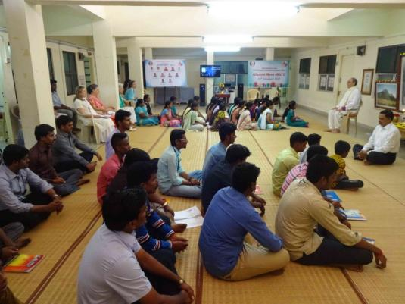

Every Sunday we offer our students placement services and soft skills training in:

-English language

- Embedded Systems (for engineering students)

- Computer classes

- General knowledge

- Training on renewable energy (solar)

- Coaching for job applications and interviews

- Counselling

These skills increase the chances of our graduates to compete successfully in today’s tough job markets.

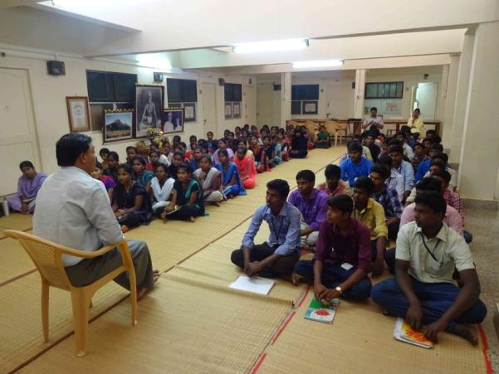

**Medical Aid From Shanthimalai Trust to poor patients through SriRamana Maharishi Health Society.**

Sri Ramana Maharishi Health Society, Athiyandal, which had been catering to the medical need of the poor people, living around this area, Shanthimalai Trust supportsblind, deaf and dumb, physically challenged person, patients with seizure disorders, HIV and AIDS, leprosy, senior citizens (above 60 years), sadhus and sannyasis, mentally retarded children, etc..Since April 1st2011 the Health Society continued to offer these services to this kind of patients. Most of the charges for these treatmentswere met by Shanthimalai Trust. Apart from these patients, certain chronic patients like end-stage renal failure undergoing routine dialysis, psychiatric cases, hemiplegic cases, neurological disorder cases were referred to higher institutions for further management and received Medical Aid for their treatment through Shanthimalai Trust on a regular basis. In future the Health Centre will collaborate with Vision Paramedical Society, Tiruvannamalai, for training of students in the paramedical fields, which will also benefit our PTP program.

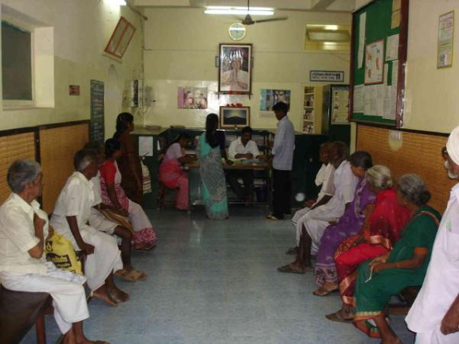

Reception of Sri RamanaMaharshi Health Centre